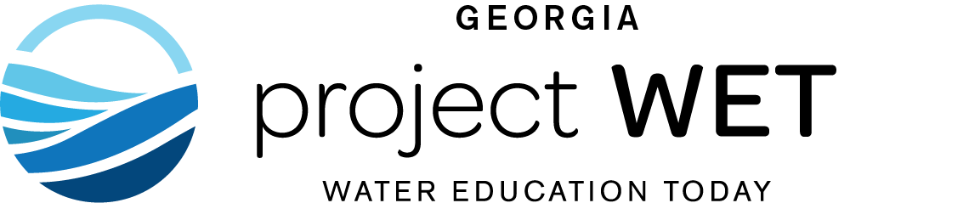

Project WET

Educator Workshop

Receive the Project WET Curriculum and Activity Guide

and become a certified educator in Project WET.

November 1 at Epworth by the Sea, St. Simons Island 9:00AM-3:30PM

Registration fee: $40.00, includes WET curriculum, resources, and lunch!

Join us for this exciting workshop and become certified as a Project WET (Water Education for Teachers) Educator! Upon completion of this workshop, you will be certified as a
Project WET Educator.

REGISTRATION DEADLINE: October 18
Space is limited, and you must attend the entire workshop to become certified.
TO REGISTER, COMPLETE AND RETURN THE FORM BELOW.

Confirmation information (including directions, location information and workshop details) will be sent to all registered participants.

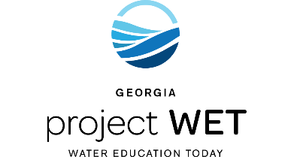
Questions? Call (xxx) xxxxxxx.

Project WET Workshop REGISTRATION FORM
Date, Location

Name: _

Address: _

City, State, Zip & County:__________________________________________________________

Phone:________________________________ Grades you reach: ________________

Email: ______________________________________

Organization: _

Please return this completed form
with your $40 check made payable to: xxxxxx

Send to:
Name
Address

