Rain turns fields to mud
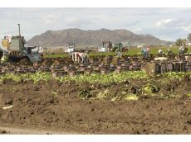
PHOTO BY CRAIG FRY/YUMA SUN
NEITHER WIND, nor rain, nor mud can keep the fields from being harvested in Yuma. Workers slog through muddy fields on 24th Street between Avenues C and D on Friday, picking lettuce.

The storms bringing unusual moisture to Yuma, Arizona are something of a mixed blessing.
Interview Kurt Nolte, director of Yuma County Cooperative Extension.
“They've driven up the price of lettuce some 30 percent. That's the good news," he said. "But it would be better if growers could get into the fields to harvest it."
Initial estimate Friday morning, after 1.95 inches of rain fell the day before, was that fresh vegetable harvesting was only 30 to 40 percent of its capacity.
And those who were in their fields fought saturated soil, standing water and mud that made it extremely difficult to operate harvesting equipment.

Nolte said he observed one tractor sunk in at least three feet of mud.
"It's taking as many as three tractors to pull one harvesting rig through the mud. It's like a swamp in some locations."
In other cases, equipment has been abandoned and workers are doing by hand what they usually did with the help of equipment, Nolte said. He said he saw crews packing head lettuce on the ground without the use of a harvesting rig. Hardest hit, he said, is the harvesting of the baby leaf mix, usually cut mechanically by a rowing-type machine. "They can't get the machines into the fields to cut. So they've returned to hand labor for the baby leaf. That's really inefficient." It's also miserable for those who are working in the cold and wet and mud, he said.
"It's all driven by the lettuce already being sold," Nolte said. "The orders need to be filled ... people need to eat. So they keep the stream flowing in the middle of the muck." Less clear is the rain's impact on the freshly planted fields, or the fields that are due to be planted, cultivated, weeded, thinned or fertilized.
And more rain is forecast.
While it's challenge enough to continue harvesting despite the storms, Nolte said, the greater concern is the long-term damage caused by working in the fields when they're muddy.
"Significant ruts are being worn in the fields two or three feet deep. Tractors are up to their axles. It's like a birthday cake being crushed by your hand. There will be significant soil for years to come.”

Atlanta Floods Extremely Rare
ScienceDaily (Nov. 9, 2009) — The epic flooding that hit the Atlanta area in September was so extremely rare that, six weeks later this event has defied attempts to describe it. Scientists have reviewed the numbers and they are stunning.
Interview Water Professionals "At some sites, the annual chance of a flood of this magnitude was so significantly less than 1 in 500 that, given the relatively short length of streamgauging records (well less than 100 years), the U.S. Geological Survey cannot accurately characterize the probability due to its extreme rarity," said Robert Holmes USGS National Flood Program Coordinator. "Nationwide, given that our oldest streamgauging records span about 100 years, the USGS does not cite probabilities for floods that are beyond a 0.2 percent (500-year) flood."
"If 500-year flood was a cup of coffee, this one brewed a full pot," said Brian McCallum, Assistant Director for the USGS Georgia Water Science Center in Atlanta. "This flood overtopped 20 USGS streamgauges -- one by 12 feet. The closest numbers we have seen like these in Georgia were from Tropical Storm Alberto in 1994. This flood was off the charts."
The rains returned water levels in the region's two largest reservoirs, Lake Lanier and Allatoona Lake, to pre-drought levels. Lake Lanier rose by more than three feet to 1068 feet by Sept. 25 and returned to full pool in October. Allatoona Lake rose to 853.25 feet on Sept 23, more than 13 feet over full pool of 840 feet.
"The flooding in Atlanta is certainly near the top of the list of the worst floods in the United States during the past 100 years," said Holmes. "For comparable drainage areas, the magnitude of this flood was worse than the 1977 Kansas City flood, which caused tremendous destruction and loss of life. It is a testament to the diligence of county officials and emergency management teams that more lives were not lost in Georgia."
"Applying rainfall frequency calculations, we have determined that the chance of 10 inches or more occurring at any given point are less than one hundredth of one percent," said Kent Frantz, Senior Service Hydrologist for the National Weather Service at Peachtree City. "This means that the chance of an event like this occurring is 1 in 10,000."
- In Cobb County, Sweetwater, Noonday, Butler, and Powder Springs creeks flooded so severely that the annual chance of a worse event is far smaller than 0.2 percent (500-year) flood. On Sweetwater Creek near Austell, Ga., high-water marks showed a peak stage of 30.8 feet.
- In Douglas County, the Dog River near Fairplay overtopped the USGS stream gauge by 12 feet.
- Gwinnett, DeKalb and Rockdale counties also had record flooding. Suwanee Creek floods were beyond the 0.2 percent annual exceedence probability (500-year) flood.
- On the Chattahoochee, the USGS gauge at Vinings reached a peak stage of 28.12 feet.
In Georgia the USGS maintains a network of nearly 300 streamgauges that provide data in real time. Data from these streamgauges are used by local, state and federal officials for numerous purposes, including public safety and flood forecasting by the National Weather Service.

Urban Growth Versus Global Warming
ScienceDaily (Oct. 22, 2009) — Houses on stilts, small scale energy generation and recycling our dishwater are just some of the measures that are being proposed to prepare our cities for the effects of global warming.
A three-year project led by Newcastle University for the Tyndall Centre for Climate Change Research has outlined how our major cities must respond if they are to continue to grow in the face of climate change.
Using the new UK Climate Predictions ’09 data for weather patterns over the next century, the research looks at the impact of predicted rises in temperature - particularly in urban areas - increased flooding in winter and less water availability in summer.
The report “How can cities grow whilst reducing emissions and vulnerability” focuses on the particular challenges facing London but can be used as a model for other cities on how policy-makers, businesses and the public must work together to prepare for climate change.
As well as protecting our homes and buildings against the increased threat of flooding from rising sea levels, the report emphasizes the need to reduce our carbon emissions, reduce our water usage and move towards cleaner, greener transport.
Interview Newcastle University’s Dr Richard Dawson, researcher. Dr Richard Dawson said: “There’s not one simple solution to this problem. Instead we need a portfolio of measures that work together to minimize the impact of climate change while allowing for our cities to grow.
“Most importantly we have to cut our carbon dioxide emissions but at the same time we need to prepare for the extremes of weather – heat waves, droughts and flooding – which we are already starting to experience.
“The difficulty is balancing one risk against another while allowing for the expected population and employment growth and that is what our work attempts to address.”
The project is the result of three years’ work to decide how our cities should respond to the threats of climate change.
Promoting the development of cycleways and public transport, low-carbon energy and water recycling it also shows how solving one problem can exacerbate another.
Dr Dawson explains: “Heat waves like the ones being predicted to occur more frequently in future are extremely serious, particularly for the eldest members of our population.
“To combat the problem we often resort to switching on the air conditioning. This is not only energy intensive (and therefore has potential to raise carbon dioxide emissions that drive climate change) but works by cooling the inside of the building and expelling hot air outside, raising the overall air temperature in the city as well.
"Good planning is the key - we have shown that land use planning influences how much people travel and how they heat and cool their buildings, and hence the carbon dioxide emissions.
Vagrants Find 'Home' in Tunnels Under Vegas Casinos: Tunnel dwellers trade danger of drowning for a little comfort
(Newser) – Flood tunnels beneath the casinos of Las Vegas seem an unlikely place to call home. But that’s exactly what they are to an estimated 700, including some who’ve built surprisingly elaborate makeshift dwellings in the 350-plus miles under the city. The Sun describes the “home” of couple Steven and Kathryn, who have a double bed, bookshelves and even a shower—made from a drinking-water dispenser.
Interview Tunnel dwellers. “One man’s junk is another man’s gold,” explains Steven.” Many in the tunnels have drug or alcohol problems, sustaining themselves by “credit hustling”—looking for winnings left by in slot machines by drunken gamblers. The tunnels are more comfortable than the streets, but that comfort is a dangerous illusion, explains a writer who has studied the community. “It doesn’t rain much in Nevada but when it does the tunnels can fill very quickly,” he says—leading to 20 drownings the past 20 years.

Eight Dead in Southeast Floods
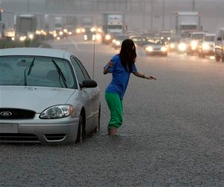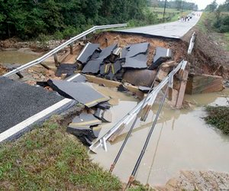
(AP) – Washed-out roads and flooded interstate highways around Atlanta added to the misery today after days of torrential rain in the Southeast that claimed at least eight lives, including a 15-year-old boy whose body was found in the Chattooga River. Authorities urged people who don't need to drive to stay home, a day after Georgia Gov. Sonny Perdue declared a state of emergency in 17 counties.
Interview DOT spokeswoman. "It's going to be a long morning. We're asking people to be patient," said a Department of Transportation spokeswoman. The good news was that the rain was tapering off in many areas. The National Weather Service said there was more rain to come, but the likelihood and severity will decline in the coming days. Days of downpours have saturated the ground from Alabama to western North Carolina, just months after an epic two-year drought in the region ended.

Powerful Storm Arrives in Southern California, 500 Homes Under Mandatory Evacuation
February 9, 2010
LOS ANGELES -- Residents in mudslide-prone areas are fleeing their homes as a new "vigorous" storm begins to pound the area.
Los Angeles County officials have ordered mandatory evacuations for more than 500 homes in the burn areas as a precaution.
Residents in certain areas of La Crescenta, La Canada and Acton were told to be out of their homes by 10 a.m. Tuesday. Sheriff's deputies have been knocking on doors, encouraging people to pack up and leave in advance of rainfall forecast for Tuesday and Wednesday.
The evacuation orders also include Soledad Canyon and Aliso Canyon.
The new round of wet weather comes just days after heavy weekend downpours that triggered mudslides that damaged more than 40 homes in the La Cañada Flintridge area.
Interview The National Weather Service person, “Rain could come down at a rate of a half-inch to an inch per hour Tuesday afternoon and evening, raising the threat of mud and debris flow in the burn areas.”
There's also a 40 percent chance of showers Wednesday morning and a 20 percent chance of rain on Friday, forecasters said.
Tuesday's storm is expected to bring showers, thunderstorms, heavy snow in upper elevations, high winds and the threat of tornadoes, hail and flash flooding.
"It appears that the highest rainfall totals will occur across Los Angeles County, especially across eastern sections, including the Station and Morris Burn areas," according to an NWS advisory.
Snow levels are expected to fall to between 3,000 and 4,000 feet Tuesday night. There is even a chance that snow could fall as low as 2,500 feet, according to the NWS.
Forecasters say the conditions will likely impact the Interstate 5 corridor near The Grapevine.
Meanwhile, crews are still digging out from the last storm that spawned mud and debris flows in the Station Fire burn area.
Forty-three homes in La Cañada Flintridge were damaged when a debris basin clogged during a weekend storm and overflowed. Nine homes were red tagged as uninhabitable.
More than 500 homes were evacuated, although the order was later lifted.
Crews concentrated on removing large debris that could clog drains and cause overflows and on scraping the ooze off roads in high-risk communities so people can flee and rescuers can get in during an emergency.

Trashed
Across the Pacific Ocean, Plastics, Plastics, Everywhere
CHARLES MOORE / Natural History v.112, n.9, Nov03
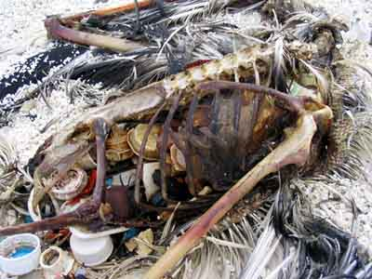
Bottle caps and other plastic objects are visible inside the decomposed carcass of this Laysan albatross on Kure Atoll, which lies in a remote and virtually uninhabited region of the North Pacific. The bird probably mistook the plastics for food and ingested them while foraging for prey.
It was on his way home, after finishing the Los Angeles-to-Hawaii sail race known as the Transpac, that Charles Moore’s sailing crew first caught sight of the trash, floating in one of the most remote regions of all the oceans.
Interview CHARLES MOORE. “Throughout the race our strategy, like that of every other boat in the race, had been mainly to avoid the North Pacific subtropical gyre-the great high-pressure system in the central Pacific Ocean that, most of the time, is centered just north of the racecourse and halfway between Hawaii and the mainland. But we decided to take a shortcut through the gyre, which few seafarers ever cross. Fishermen shun it because its waters lack the nutrients to support an abundant catch. Sailors dodge it because it lacks the wind to propel their sailboats.
I often struggle to find words that will communicate the vastness of the Pacific Ocean to people who have never been to sea. Day after day, Alguita was the only vehicle on a highway without landmarks, stretching from horizon to horizon. Yet as I gazed from the deck at the surface of what ought to have been a pristine ocean, I was confronted, as far as the eye could see, with the sight of plastic.
It seemed unbelievable, but I never found a clear spot. In the week it took to cross the subtropical high, no matter what time of day I looked, plastic debris was floating everywhere: bottles, bottle caps, wrappers, fragments. Months later, after I discussed what I had seen with the oceanographer Curtis Ebbesmeyer, perhaps the world's leading expert on flotsam, he began referring to the area as the ‘eastern garbage patch.’ Ebbesmeyer has estimated that the area, nearly covered with floating plastic debris, is roughly the size of Texas.”

Historically, the kind of drastic accumulation encountered is a brand-new kind of despoilment. Trash has always been tossed into the seas, but it has been broken down in a fairly short time into carbon dioxide and water by marine microorganisms. Now, however, in the quest for lightweight but durable means of storing goods, we have created a class of products—plastics—that defeat even the most creative and voracious bacteria.
Unlike many discarded materials, most plastics in common use do not biodegrade. Instead they "photodegrade," a process whereby sunlight breaks them into progressively smaller pieces, all of which are still plastic polymers. In fact, the degradation eventually yields individual molecules of plastic, but these are still too tough for most anything—even such indiscriminate consumers as bacteria—to digest. And for the past fifty years or so, plastics that have made their way into the Pacific Ocean have been fragmenting and accumulating as a kind of swirling sewer in the North Pacific subtropical gyre.
The subtropical gyres are also oceanic deserts in fact, many of the world's land-based deserts lie at nearly the same latitudes as the oceanic gyres. Like their terrestrial counterparts, the oceanic deserts are low in biomass. On land the low biomass is caused by the lack of moisture; in oceanic deserts the low biomass is a consequence of great ocean depths.
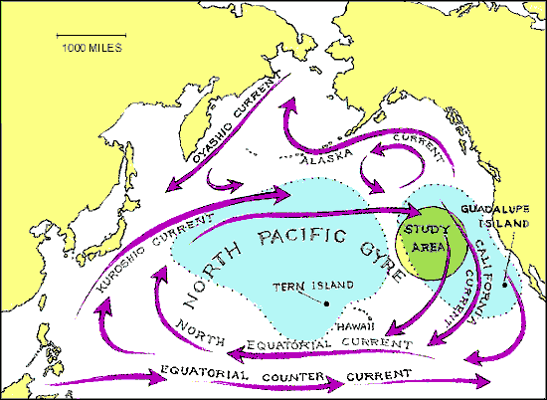
What does exist in the gyres is a great variety of filter-feeding organisms that prey on the ever-renewed crop of tiny plants, or phytoplankton. Each day the phytoplankton grow in the sunlit part of the water, and each night they are consumed by the filter feeders, a fantastic array of alien-looking animals called zooplankton.
Leecaster and Moore came up with a plan to make a series of trawls with a surface plankton net, along paths within a circle with a 564-mile radius.
“What we saw amazed us. We were looking at a rich broth of minute sea creatures mixed with hundreds of colored plastic fragments-a plastic-plankton soup. There was plenty of larger debris in our path as well, which the crew members retrieved with an inflatable dingy In the end, we took about a ton of this debris on board.”
“The scale of the phenomenon is astounding. I now believe plastic debris to be the most common surface feature of the world's oceans. Because 40 percent of the oceans are classified as subtropical gyres, a fourth of the planet's surface area has become an accumulator of floating plastic debris. What can be done with this new class of products made specifically to defeat natural recycling? How can the dictum "In ecosystems, everything is used" be made to work with plastic?”

Already buried under 3 feet of snow, Mid-Atlantic prepares for 2nd big storm; Midwest also hit

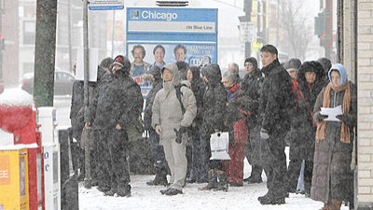
February 9, 2010

WASHINGTON (AP) — Snow blew across the Midwest on Tuesday and headed for the hard-hit Mid-Atlantic region, where federal government offices have been closed since last week and utility workers struggled to restore power already knocked out by a weekend blizzard.
The latest storm hit the Midwest early, closing schools and greeting commuters with slick, slushy roads from Minneapolis and Chicago to Louisville, Ky. Hundreds of flights were canceled at Chicago's airports as the storm moved across Illinois, where up to a foot of snow was forecast.
Powerful winds and snow were expected to hit Mid-Atlantic states by the afternoon, and could leave as much as 20 inches of new snow in Washington and 18 inches near Philadelphia — a Northeast travel hub — by Wednesday night. New York City announced students would have a rare snow day Wednesday, only the third in six years.
Parts of the region were already buried under nearly 3 feet.
In rural Maryland, a state police helicopter rescued a man stranded in a remote mountaintop home where he had been staying alone with no electricity since the storm this past weekend.
On Capitol Hill, the House called off all votes for the week because many members couldn't get back from their districts.
The White House, meanwhile, moved a Black History Month concert featuring Bob Dylan, Smokey Robinson and Natalie Cole up a day to try to beat the storm. President Barack Obama held a bipartisan meeting with congressional leaders and joked that it went so well that Reid and Republican Sen. Mitch McConnell of Kentucky had gone out to play in the snow.
"In fact, I understand that McConnell and Reid are out doing snow angels on the South Lawn together," Obama joked as he made an unannounced stop in the White House briefing room.
Residents worried they might be stuck at home hit grocery stores to stock up. A Safeway grocery store in the Dupont Circle area of Washington had milk and some bread Tuesday, but many other items were picked over from the last storm. There was no shredded cheese, and people who wanted Diet Coke or Brussels sprouts were out of luck.

Uruguay floods prompt more than 5,000 people to flee; water, power service cut
February 9, 2010

MONTEVIDEO, Uruguay (AP) — Flooding in Uruguay has swamped roads and homes, forced thousands to evacuate and cut power and water service.
Hardest-hit is the central province of Durazno, where the Yi River overflowed its banks.
Durazno's emergency agency says 3,000 people were evacuated and another 1,500 left home on their own. Health authorities are working to truck potable water to regions left without service.
In Soriano province, an undetermined number of people have fled the rising Negro River.
And in Rocha, officials released water from behind a dam that reached record levels.
Farm official Anibal Garcia Ricci said Tuesday that several Rocha towns are cut off, and about 170,000 acres (70,000 hectares) of cropland are threatened.
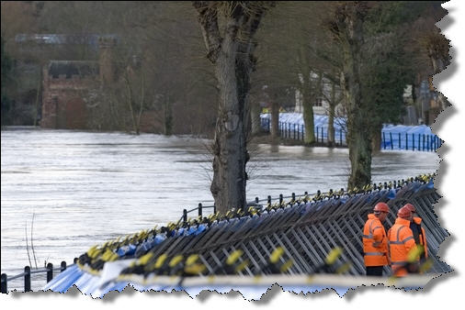
Controlling Nonpoint Source Pollution
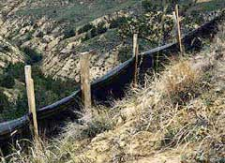
Sediment fences such as this are used to control erosion, trap large materials, filter sediment from rainwater, and slow runoff.
While research, monitoring, and assessment look at the larger environmental effects of nonpoint source pollution, taking measures to stop pollution before it begins is also essential for controlling the problem.

This is especially true in coastal communities. According to a NOAA Coastal Population Trends Report, about 153 million people lived in coastal areas in 2003. This is 53 percent of the total U.S. population. Between 1980 and 2003, the total coastal population increased by 28 percent, or 33 million people (Crossett et al., 2004.) If coastal populations continue to grow, the chances for more nonpoint source pollutants such as nutrients, sediments, pesticides, and other toxic chemicals to enter waterbodies via runoff increases.
Even though the exact locations of nonpoint source pollution cannot be identified, scientists know that certain environments and operations produce a high volume of pollution. Experts have developed systems to reduce and even eliminate pollution from these places. Listed below are some strategies that urban and suburban areas, agricultural operations, forestry operations, and marinas use to decrease nonpoint source pollution.

Trash traps given a tryout Ventura tests devices to curb urban runoff
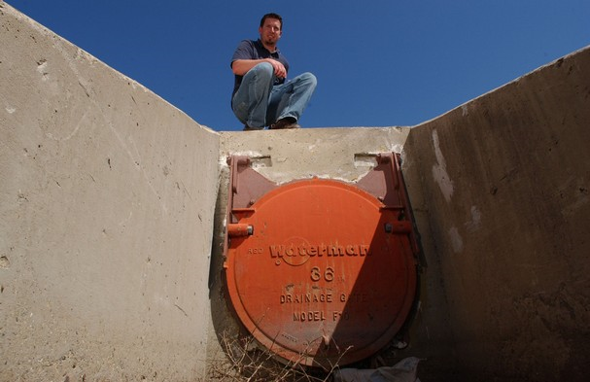
Photo by Eric Parsons
Chris Palmieri, a Ventura streets supervisor, crouches near one of the storm drain outfalls along Ventura Avenue. The city has joined a program to test trash excluders, screens put over drains to capture runoff that would otherwise end up in the Ventura River estuary.
A noxious cluster of trash — plastic-foam containers, cigarette butts, greasy fast-food wrappers, a rotting potato — was on a crash course for the Ventura River estuary.
But it never made it. Instead, the refuse was trapped inside an underground catch basin by a "trash excluder" — a stainless-steel screen with holes no larger than 5 millimeters fastened over a runoff pipe leading to the river.
The custom-made devices, which cost about $1,000 each, are Ventura's newest, low-tech effort to curb the growing volumes of urban debris that mar wetlands and spoil water quality.
Interview Chris Palmieri, a city streets supervisor: "It's amazing how well these contraptions work," Chris Palmieri, said moments after he removed a sidewalk manhole, revealing two wheelbarrow loads of waste captured by the new screen.
Palmieri has installed five excluders along Ventura Avenue as part of a pilot program to test their effectiveness. The trash will remain captured in the underground basin until later removed and recycled or taken to a landfill.
Some predict the units could be the first of dozens, possibly thousands, installed across the county in response to tough new regulations intended to keep trash, bacteria and other pollutants out of local waters.
Disgusted by the volume of trash and pollutants that reaches area waterways and the Pacific Ocean, the Los Angeles Regional Water Quality Control Board has proposed the aggressive new regulations for storm water.
The regulations, to be shared by county government and all 10 cities, remain in draft form and likely won't be finalized until October at the earliest.
Ventura, Calif. officials agree something should be done about the trash. But they, like others in the county, would prefer the flexibility to chose how to best handle the trash situation in their communities.
Interview Mark Gold president of Heal the Bay, a Santa Monica-based environmental group: “Ideally, people and businesses wouldn't litter. But until behaviors dramatically change, the excluders are gaining popularity as an effective, relatively low-cost method to keep trash from reaching the sea,” said Mark Gold. “The city and county of Los Angeles have installed more than 40,000 of the units,” he said.
"They are becoming popular because they are easy to install and relatively cheap," he said.
But he was quick to warn of the drawbacks. "The one downside is that people need to be aware these devices are not the panacea to rid all our pollutions," he said. "The most harmful stuff is often not what you see."
Pet waste, fluids dripping from automobiles, household chemicals, lawn fertilizer and garden pesticides often spill into runoff systems as rain falls on streets, sidewalks, roofs and other impermeable surfaces that cover most of the land in urban areas.
"Litter harms the river ecosystem, everyone knows that," Gold said. "These excluders will cut down on the trash reaching the river. But for now, there are only five, so it's going to take everyone doing their part."

