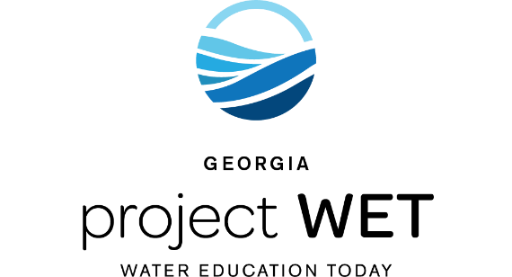
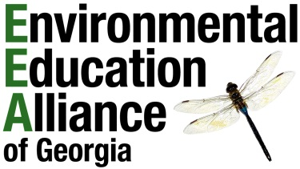

RECEIPT

Georgia Project WET
(Water Education Today)

in partnership with the

Environmental Education Alliance of Georgia

DESCRIPTION OF ITEMS | QUANTITY | UNIT PRICE | TOTAL PAID
Project WET 2.0 Curriculum & Activity Guide  Certification Training | 1 | $ | $

PAID BY:

ORGANIZATION:

State Coordinator

Georgia Project WET

GEORGIA PROJECT WET
ENVIRONMENTAL PROTECTION DIVISION
2 MLK Jr. Dr., Suite 1462
Atlanta, GA 30334
projectwet.ga.gov

Please call (404) 651-8521 if you have any questions regarding this receipt.
Thank You for Getting WET!

